**Bootstrap Examples**

**Bootstrap Forms**

1. Stacked form
2. Inline form

**Stacked Form**

1. We have class name as .form-group(wrapper class)
2. Form-control for the input fields

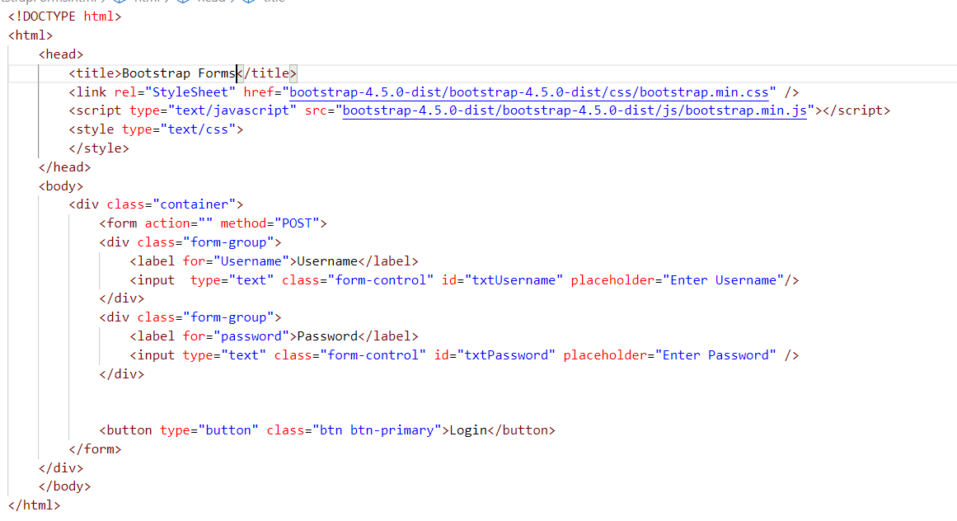

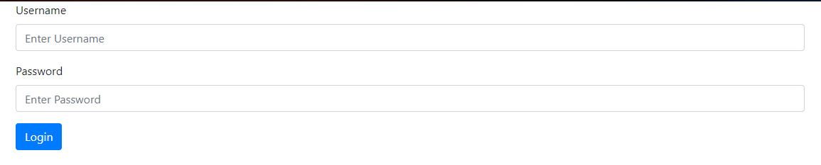

**Inline form**

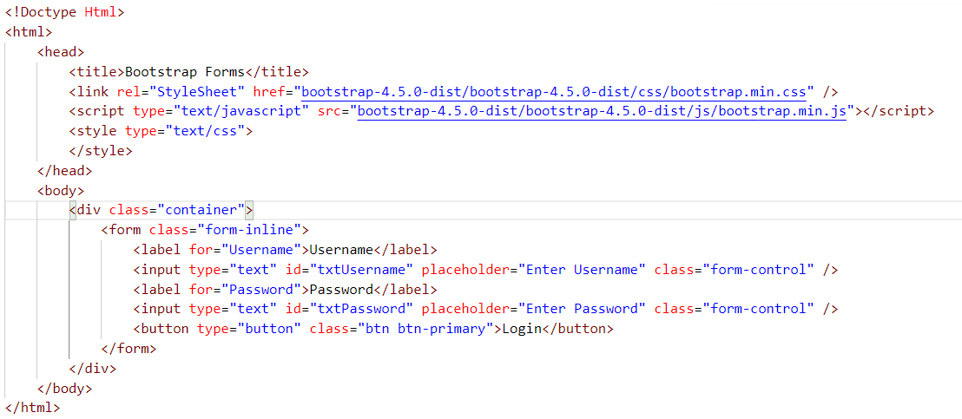



**Rows and Columns**

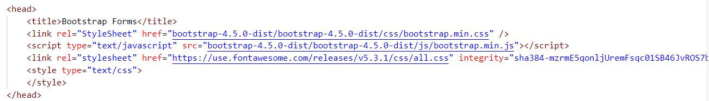

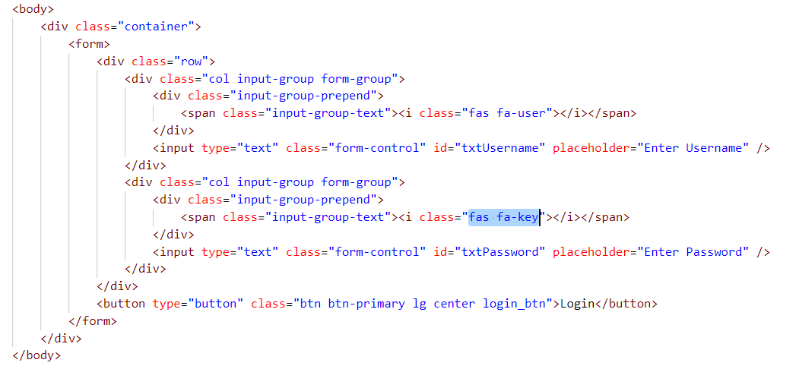

**Bootstrap NavBar**

